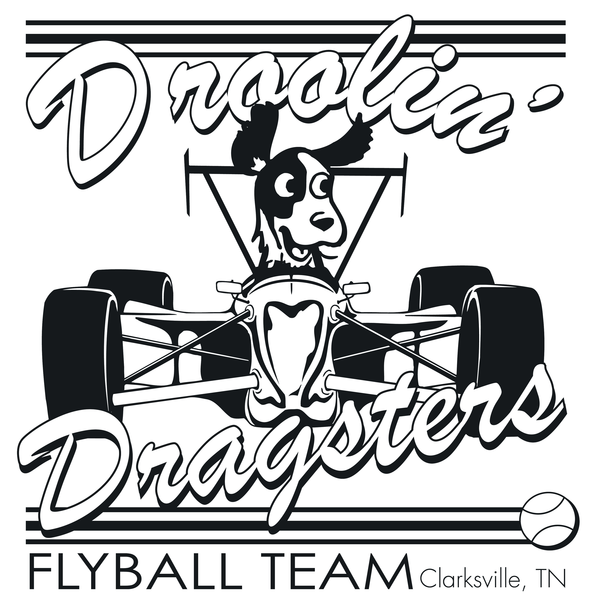

Website: www.c-c-s-a.com
Email: droolindragsters@gmail.com
PayPal: droolindragsters@gmail.com

Welcome to the Furr-arri 500 NAFA Tournament!
Thank you for entering our Flyball Tournament. We look forward to seeing you on May 11th & 12th, in Hopkinsville, KY. The tournament is indoors in a climate-controlled environment. We will be running one lane with Paul Ferlitto as our judge. Jeanne Harem will act as his back up. As soon as available after closing all additional information will be posted on our website www.c-c-s-a.com and on our face book page. Sunday we will have fewer teams, and the racing schedule will be a little rough, we will do our best to accommodate any issues.

Schedule
Racing will begin at 0800 on both Saturday and Sunday.
We will have a 1 hour floating lunch on Saturday. Teams will be notified 5 races prior to the break. Sunday, we will have at least a 30 minute lunch break and it will be run and done.

Friday, May 10th
Noon Dragsters will begin setup
3 PM Teams will be allowed into the building.
6 PM Green dog racing will begin (1st come 1st serve to accommodate arrival times)
9 PM Building Closes

Saturday, May 11th

7:00 AM Building Opens
7:15 AM Box checks
7:30 AM C2 Reports due to head table and dog measuring
7:40 AM Captains Meeting
8:00 AM Racing Begins (pending all measuring being complete)
9:00 PM Building Closes

Sunday, May 12th
7:00 AM Building Opens
7:30 AM C2 Reports due to head table and dog measuring
7:40 AM Captains Meeting
8:00 AM Racing Begins

Facility Address
Western Kentucky fairgrounds
2810 Richard St.
Hopkinsville, KY 42240

Details

Tournament Scoring
Teams will receive 1 point for each heat won. Heats ending in a tie will result in each team receiving ½ point.

Placement ties will be broken by:
1. Head to Head
2. If still tied, best time overall.

Warm – Ups
On Saturday we will do a 2 minute warm up all day. Sunday we will do 2 minute warm up 1st round, 1 minute following.

Friday and Saturday Night Green dog Racing
Friday and Saturday night we will have green dog racing. It will be $10 for 10 minutes, and you will have access to both lanes. It will be limited to time available and we will assign slots and adjust as needed for arrival times. Saturday green dog will begin after racing.

Awards
Awards will be given out at the end of Saturday’s racing, and during the day on Sunday (so please keep the brag board updated).

Workers
We will only have line judges, and they will not be assigned. To thank you for your help filling chairs, we will be offering workers’ raffles each day. Please do your share and sit in a chair.

Raffles
Raffle tickets will be sold for:
$1 per ticket
$10 per 20 tickets
$20 per 40 tickets
$30 per 60 tickets
$40 per 100 tickets
$50 per 125 tickets
$60 per 150 tickets

1. Pay for your tickets at the Droolin Dragster team area.
2. Write your name, and team’s name on the ticket.
3. Place your ticket in the designated bucket.
4. At 2 PM on Sunday, tickets will be pulled

Crating
Crating and team areas will be assigned in the building.

Saturday Night Pup-Sitting
Pup sitting is available after racing Saturday for a donation of $10 per team or $3 per dog. Sign up, leave your name and contact number, go have fun. Just remember – the building closes at 9.

Doggy Clean up
PLEASE clean up after your dogs. Poop bags and disposal will be available in all the designated potty areas. Please ensure that your dog uses these areas. The small grass area just outside of the snack bar is NOT a potty area. Thank you.

Hotel

Clarion Pointe Hotel has given us the discounted rate of $65 per night, with a Pet deposit of $25.00 for the weekend, regardless of the number of dogs you have. The reservations need to be made 14 days prior to the tournament date. After which, rooms will be released to the public at regular rates. You must call the local hotel to get this deal, mention the dog show or flyball. Phone: 270-886-4413.

RV Sites
There are limited RV sites available at the facility. They are $70 for the weekend. None of the sites have sewer hookups. A few have electric and water, some have only electric. Please email droolindragsters@gmail.com for availability and hookups.

Facility Restrictions
PLEASE REMEMBER that no outside foods or drinks (other than coffee and water) are allowed INSIDE the building. The snack bar will be open for Breakfast and lunch, closing at 2PM. It is part of our contract that outside food will not be allowed in the building. If you wish to bring in a Celebration Cake, they will be approved for titles of 20,000 points and above. Please notify Gary in advance. We do not want to lose the use of the facility. Thank you for understanding, we would like to continue to hold tournaments.

